

SIGMA ENGINEERING
SERVICES, COIMABTORE
INTERNSHIP REPORT

TITLE: One-Month Internship Report on Assembly and Testing at Popular Systems
DEPARTMENT OF ELECTRONICS AND COMMUNICATION ENGINEERING

NAME : CHANDIKA K, DHARSHINI K C, GOKUL PRASANTH
V, GOPINATH M, KAVYA V, LAVANYA A.
REG NO :927623BEC020,927623BEC037,927623BEC057,
927623BEC60,927623BEC111,927623BEC122.
YEAR/SEM : III/ V
PERIOD : 01.07.2025-31.07.2025
ROLE : INTERNSHIP
DOMAIN : ASSEMBLY AND TESTI NG
LOCATION : SIGMA ENGINEERING SERVICES, COIMBATORE,
SARAVANAPATTI 64111O, TAMILNADU INDIA

Title: Assembly and Testing Processes
1. Introduction
The one-month industrial training at Popular Systems was a highly enriching learning experience that allowed me to bridge the gap between classroom knowledge and practical industrial applications. The focus of the training was on assembly and testing processes, which form the backbone of electronics hardware development. During this period, I was able to work closely with experienced professionals, observe real-time production practices, and actively participate in the workflow. This helped me understand how theoretical concepts such as circuit design, soldering, and testing are transformed into reliable, functioning electronic products. The internship also highlighted the importance of precision, discipline, safety, and teamwork in a professional environment. Overall, it was an opportunity that significantly contributed to my technical growth and professional development.

2. Company Overview
Popular Systems is a well-known electronics manufacturing and service company that provides a wide range of solutions for both industrial and consumer markets. The company’s core expertise lies in the design, assembly, testing, and servicing of electronic products. It operates in a structured environment where high emphasis is placed on quality assurance, workplace safety, and timely delivery of products. Popular Systems caters to different sectors by developing custom-designed printed circuit boards (PCBs), offering both small-scale and large-scale production. The company has a dedicated workforce and modern infrastructure that allows it to maintain efficiency without compromising quality. Its commitment to innovation, coupled with a systematic approach to electronics manufacturing, has established its reputation as a trusted name in the industry.

3. Internship Goals
The internship was designed with multiple learning objectives that went beyond technical knowledge. A major goal was to provide hands-on exposure to soldering, wiring, and PCB assembly so that I could gain confidence in handling electronic hardware. Another important objective was to learn testing procedures and troubleshooting methods, which are critical in ensuring that the final product works as expected. I was also introduced to safety practices that are strictly followed in industrial setups, particularly when dealing with sensitive equipment and electrostatic discharge (ESD)-protected environments. In addition, the internship helped me develop soft skills such as teamwork, industrial communication, and effective reporting. By working on real projects, I was able to understand the value of collaboration, responsibility, and professional discipline in a workplace.

4. Roles and Responsibilities

4.1 Assembly Work
In the assembly section, my primary responsibility was to identify and organize electronic components such as resistors, capacitors, diodes, ICs, and connectors. Handling these small components required accuracy and attention to detail since even minor mistakes could affect the functionality of the entire circuit. I learned the techniques of manual soldering, which involved carefully attaching components to PCBs while ensuring strong connections and avoiding overheating. Apart from manual soldering, I was introduced to wave soldering techniques, which are used in mass production to save time and improve uniformity. I also assisted in fixing components onto PCBs as per customer-specific designs, following circuit diagrams and layout instructions. Throughout this process, I realized the importance of maintaining neatness, alignment, and quality standards in assembly, as these directly impact the efficiency of the finished product.

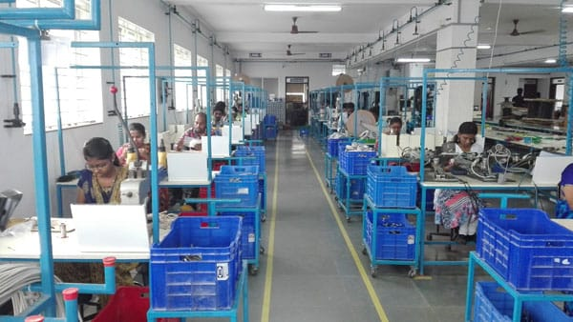
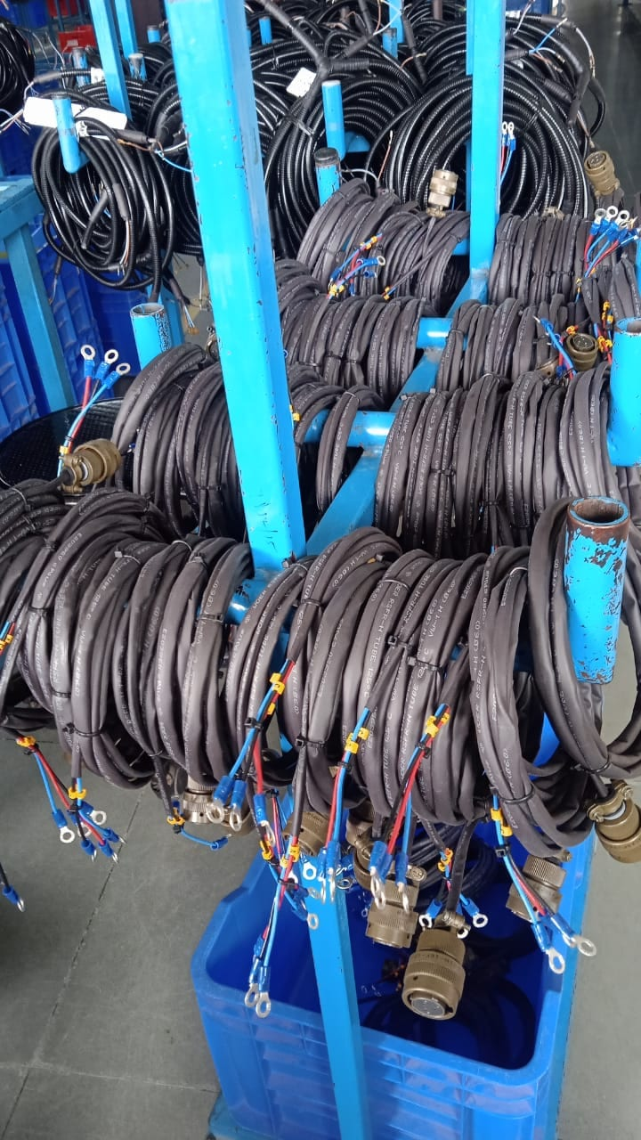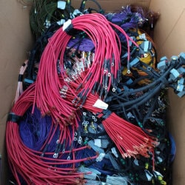
4.2 Testing Activities
In the testing department, I worked on evaluating the performance of assembled PCBs. This included conducting functional tests using instruments like multimeters, oscilloscopes, and function generators. I performed power-on tests to check voltage levels across different nodes and confirm whether the circuit was working as intended. One of the key tasks I learned was fault diagnosis, where I had to identify defective components or incorrect connections that caused the circuit to malfunction. For rework, I used desoldering tools to safely remove faulty components and replace them with new ones. In addition, I was taught the importance of documentation, where I recorded test data, prepared basic quality control reports, and reported issues to the supervisors. This section gave me valuable exposure to the importance of precision, analytical thinking, and patience in electronics testing.

5. Tools and Instruments Used
During the course of training, I became familiar with a wide range of testing and assembly equipment used in industrial environments. A digital multimeter was frequently used for measuring voltage, resistance, and continuity. I worked with soldering irons and ESD-safe soldering stations for assembly tasks, while oscilloscopes helped in analyzing waveforms and verifying signal integrity. The function generator was used for input signals during functional testing, while a continuity tester was essential in detecting open connections. Additionally, I was trained to use ferrule crimping tools for secure wire connections. Learning to handle these tools correctly and safely not only improved my technical expertise but also gave me confidence to work with professional-grade instruments.

6. Challenges Encountered
Like any industrial training, this internship came with its share of challenges that tested my adaptability and problem-solving skills. One major challenge was adjusting to the fast-paced working environment, where tasks had to be completed with both speed and accuracy. Another difficulty was handling tiny components with fine markings, which required careful attention and steady hands. Troubleshooting PCBs was also challenging, especially when multiple issues existed at the same time, making it hard to locate the exact fault. Furthermore, working in Electrostatic Discharge (ESD)-protected areas required me to strictly follow safety rules while maintaining focus for long durations. These challenges, though demanding, helped me build resilience, attention to detail, and confidence in tackling real-world engineering problems.

7. Key Learnings and Outcomes
The internship provided me with several valuable technical and professional learnings. On the technical side, I enhanced my skills in soldering, assembly, and testing, while also gaining experience in identifying faults and carrying out rework. I also learned the significance of documentation and reporting, which are crucial for maintaining quality control in industrial production. On the professional side, the internship helped me develop team collaboration, communication skills, and workplace discipline, all of which are essential in any industry. Another important outcome was the ability to connect theoretical concepts from academics to practical applications, which deepened my understanding of electronics. Overall, this training laid a strong foundation for my future projects and career aspirations in the electronics domain.

8. Conclusion
The one-month internship at Popular Systems proved to be a highly productive and insightful learning journey. By working in the assembly and testing departments, I was able to gain hands-on experience in crucial aspects of electronics manufacturing. The internship not only strengthened my technical abilities but also helped me develop a professional approach towards teamwork, quality assurance, and safety practices. I believe the skills and knowledge I acquired will play a significant role in my academic and professional growth. I am grateful to Popular Systems and my mentors for guiding me throughout this training and providing me with an opportunity to explore real-world industrial practices.

9. Acknowledgment
I sincerely thank Popular Systems for giving me the opportunity to undergo this industrial training. I am also grateful to my faculty members and department coordinators for their continuous encouragement and support during this period. Without their guidance, this experience would not have been as enriching and valuable.

PROOF PHOTO:
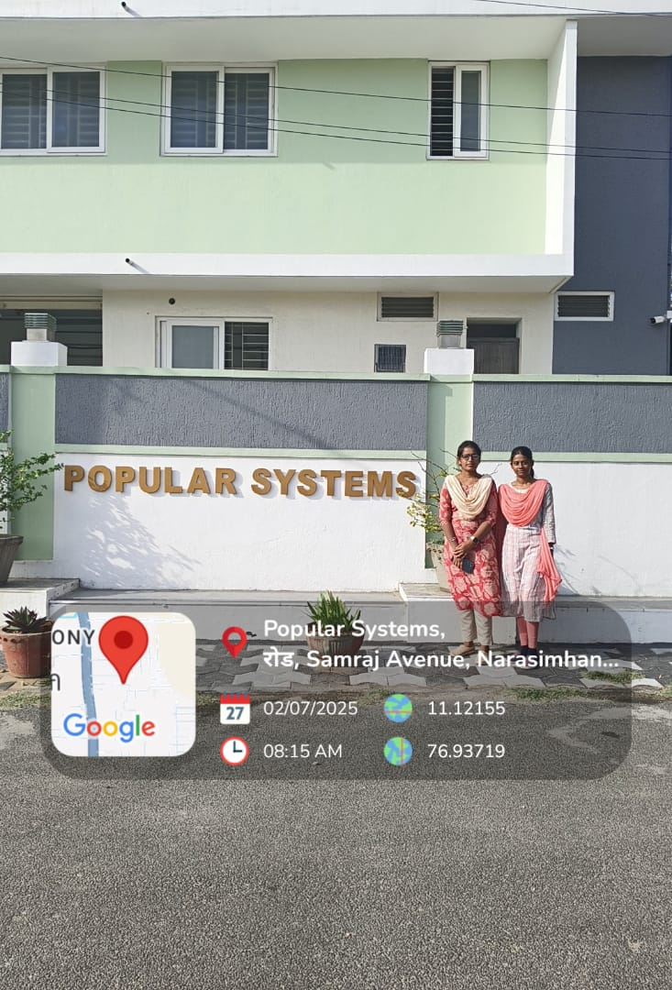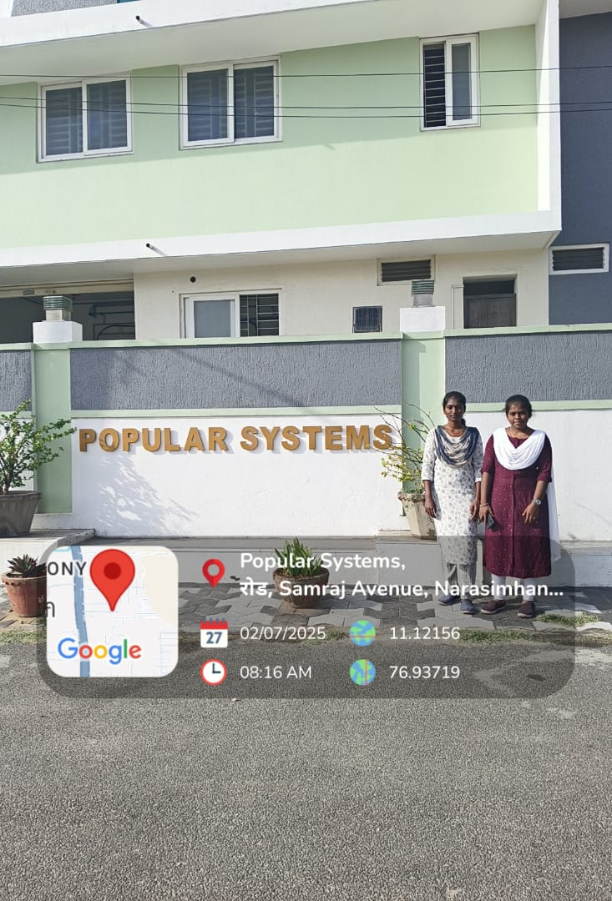

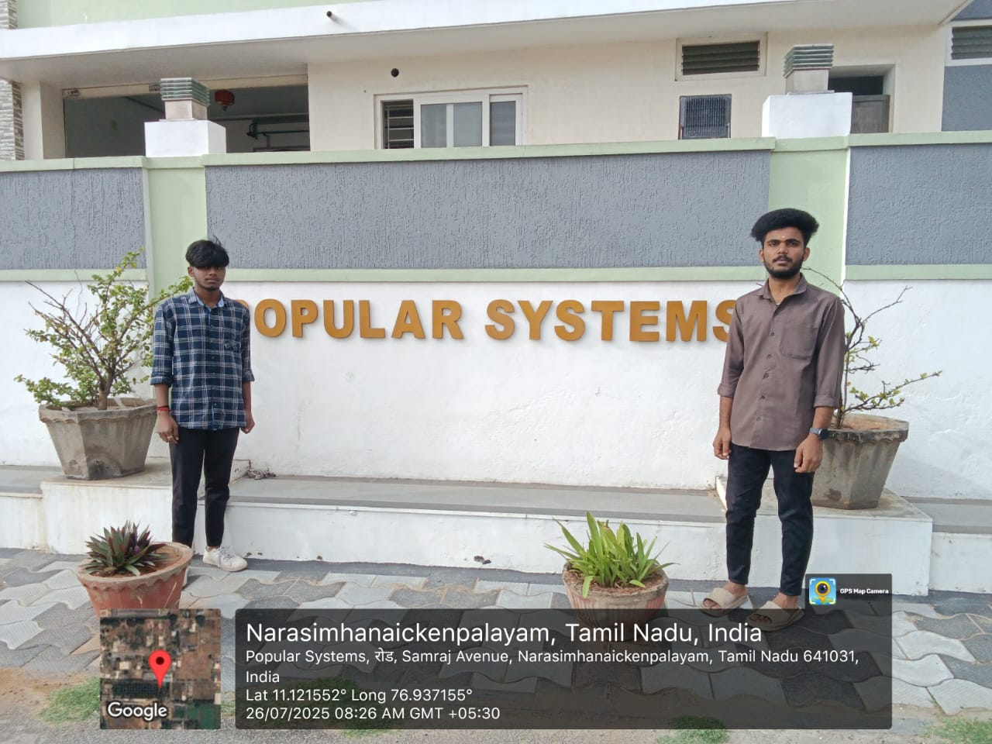

Presentation photo

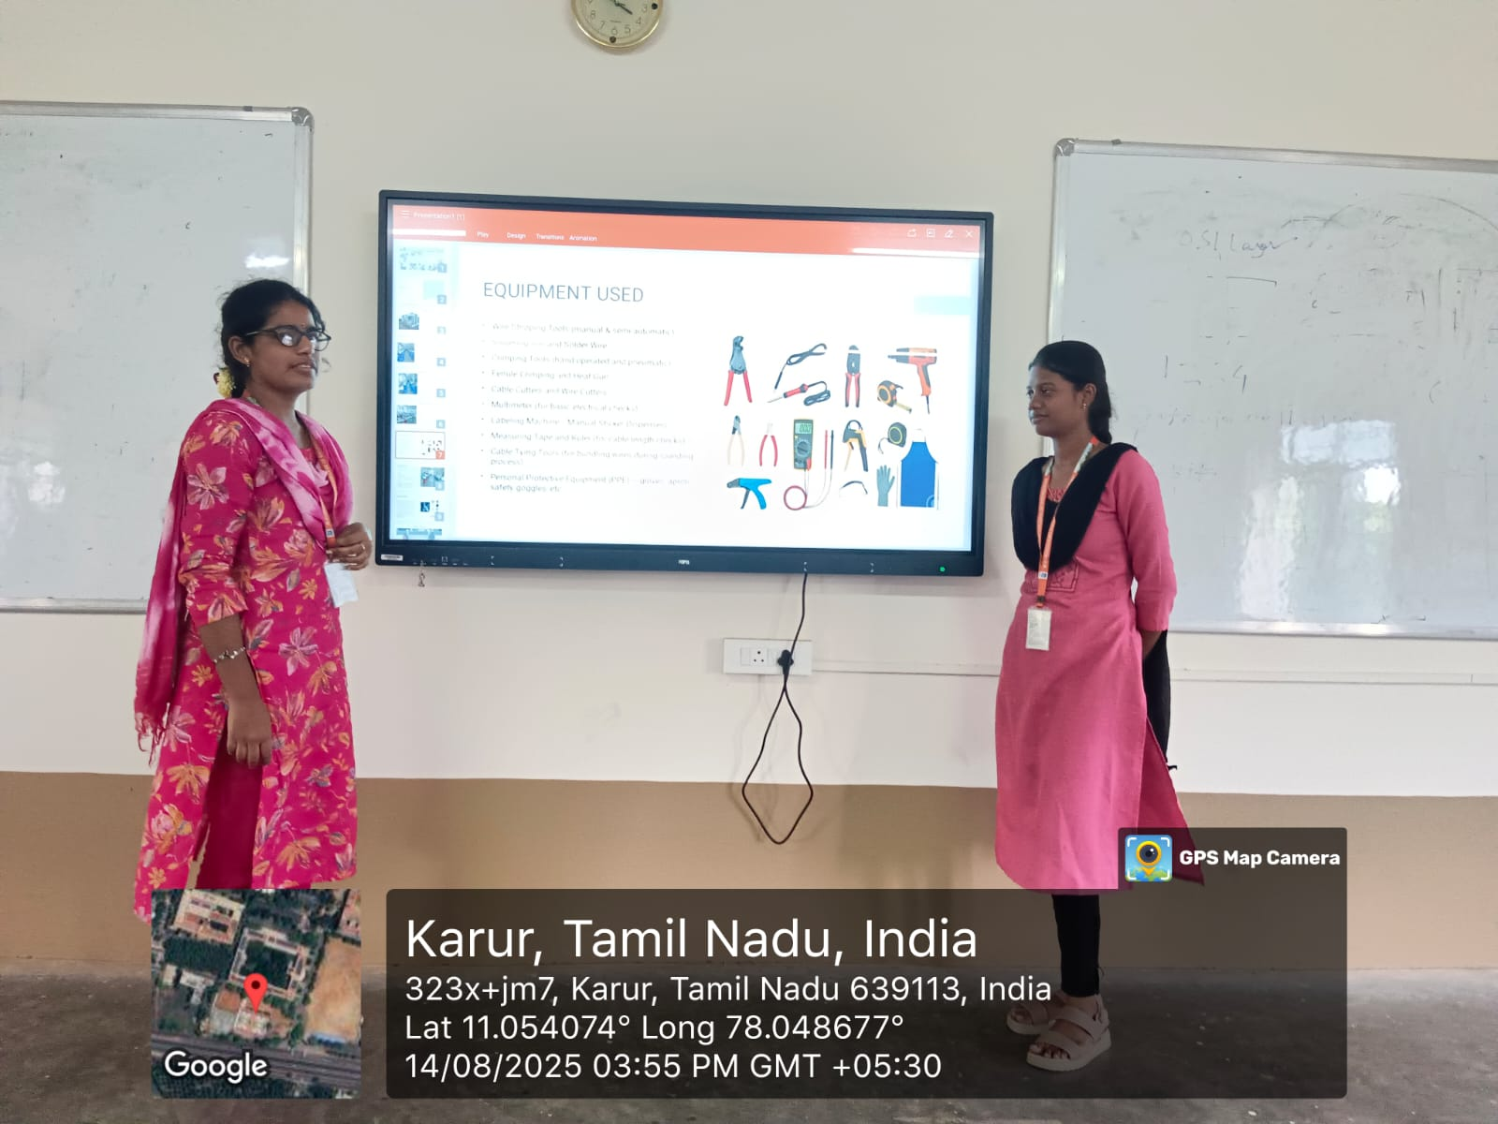

Prepared by Verified by Approved by

